2.1.1 Cell Structure Markscheme

Out of 43 marks

Section A – multiple choice
From Kerboodle objective test and sample paper
- B
- B
- A
- D
- B
Section B – short answer
From Kerboodle Exam-style questions
Question number | Answer | Marks | Guidance
1 a | Cytoskeleton | B1
1 b | (Stage) micrometer | B1
1 c | Eyepiece lens  Objective lens | B1  B1
1 d | Nucleolus | B1 | Must be spelt correctly
1 e | Ultrastructure | B1
2 a i | To stain cell / provide contrast / show nucleus | B1
2 a ii | To avoid trapping air bubbles | B1
2 a iii | To see largest area of slide / to focus more easily using coarse focus | B1
2 b | Bacteria very small / only visible at high power / grouped in clusters  Plant cells angular or rigid in shape (due to / ref. cell walls) | B1  B1 | Reference to chloroplasts does not gain credit because cereal grains do not contain chloroplasts.

Section C – long answer questions
From Exam creator
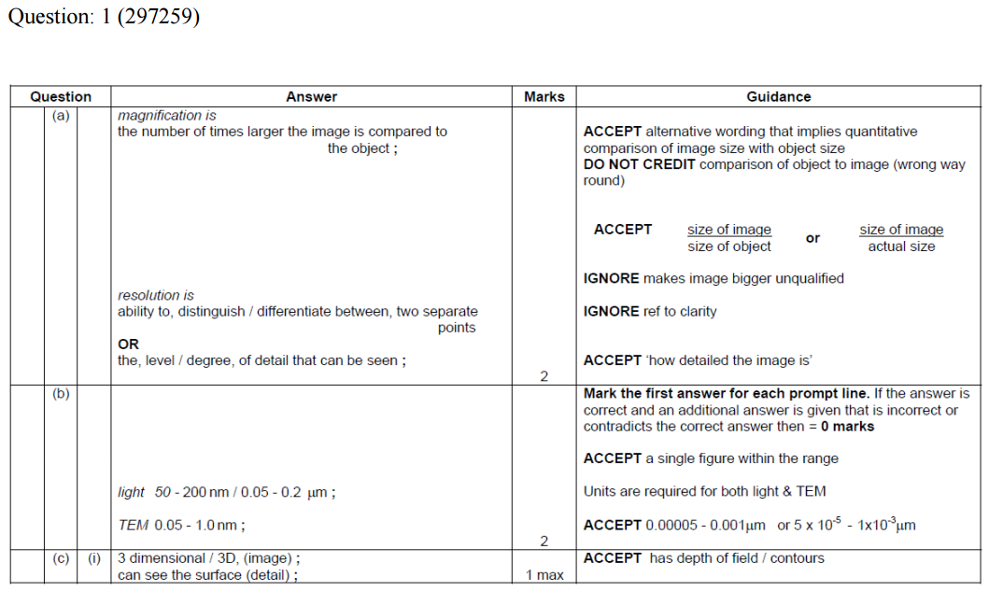
From Biology B H422/03 Practical skills in biology sample paper
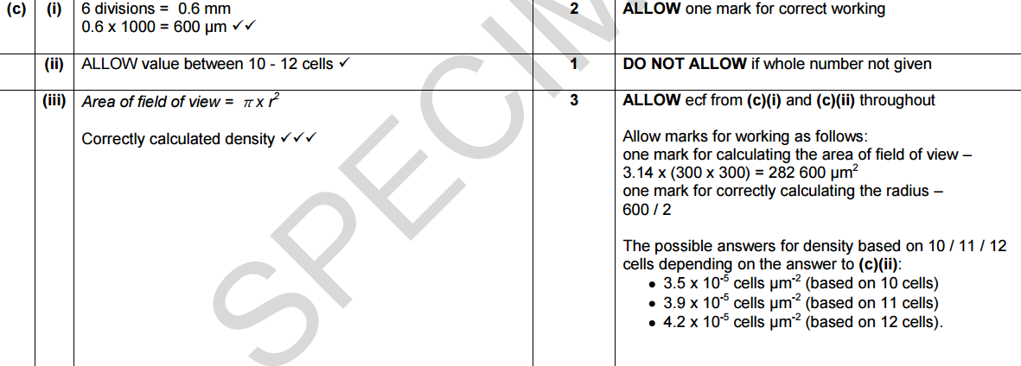
Accept answer in cells per mm²?
Question 2
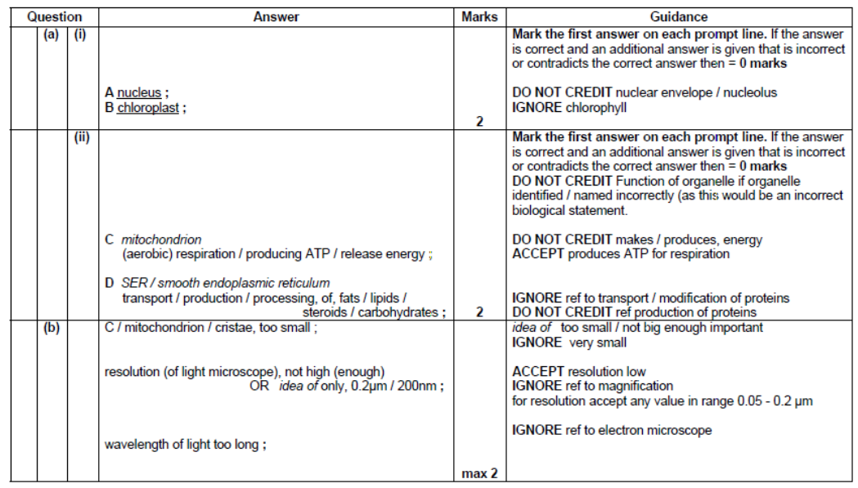
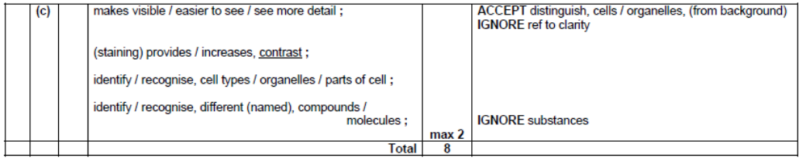

Question 3
