2.1.5 Biological Membranes Mark Scheme
Out of 48
Section A
- C
- A
- C
- A
- D
Section B
Question 1
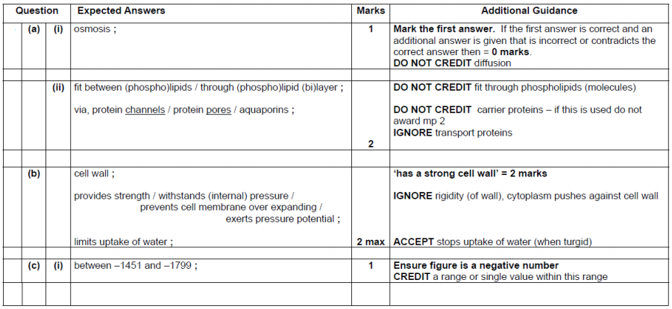
(ii) Graph:
Water potential of sucrose on the x axis and percentage of cells plasmolysed on the y AND x axis with negative numbers  BOTH axes correctly labelled with units as per headings in the table  Scales equidistant AND graph of appropriate size  Points plotted correctly  Curve of best fit correctly drawn  Correct water potential estimated from 50% plasmolysis  ALLOW plotting of sucrose concentration against percentage of cells plasmolysed if student has then looked up equivalent water potential. | 1  1  1  1  1  1 (accept ecf from incorrect lobf)

Repeatable
Note that the Practical Handbook states:
Repeatability is the precision obtained when measurement results are produced over a short timescale by one person (or the same group) using the same equipment in the same place.
Precision is the closeness of agreement between independent measurements obtained under the same conditions. It depends only on the distribution of random errors (i.e. the spread of measurements) and does not relate to the true value.
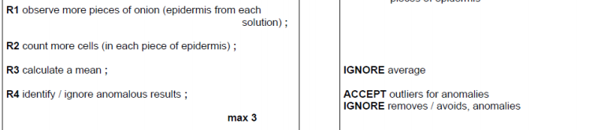

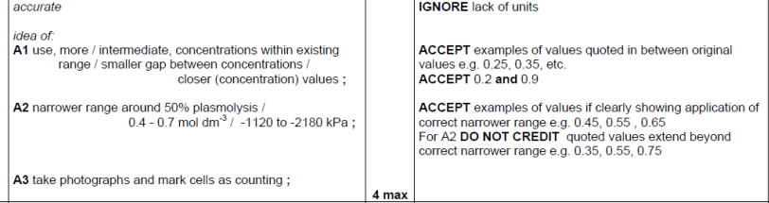

Question 2
