2.1.5 Biological Membranes End of Topic Test
NAME ________________________________________

Qu. | Topic | Marks  available | Predicted  mark | Actual mark
 | Section A – multiple choice | 5
1 | Transport across cell membranes and practical investigation skills including graph skills | 16
2 | Structure of cell membranes and practical investigation skills | 15
3 | Structure and function of cell membranes incl long answer question | 11
 | Total | 47

Reflection:

Spelling, punctuation or grammar | Maths, data analysis or experimental techniques | Application  of  knowledge | Not Reading question carefully | Clarity and precision of answer | Knowledge not revised/  understood | Statements per mark

Section A – multi-choice questions. Choose one answer for each question.

1) Which one of the following is a function of phospholipids in a cell membrane?
- To act as an antigen.
- To make the cell membrane rigid.
- To make a cell membrane more flexible.
- To act as a barrier to lipid soluble substances.
Answer: ______

2) Which molecule is required to provide the energy for active transport?
- ATP
- NADH
- ADP
- Glucose
Answer: ______

3) The rate of diffusion is proportional to surface area x difference in concentration.
length of diffusion path
What would happen to the rate of diffusion if the surface area and the length of diffusion path are halved?
- The rate of diffusion would be trebled.
- The rate of diffusion would be halved.
- The rate of diffusion would remain the same.
- The rate of diffusion would be doubled.
Answer: ______

4) A cube of potato was placed in a liquid with a water potential of –0.5 kPa. The cube of potato increased in mass. What could we conclude about this liquid?
- The liquid is not water.
- The liquid is isotonic.
- The liquid has a lower water potential than the liquid inside the potato cube.
- Solutes from the liquid are transported into the potato cube.
Answer: ______

5) A drug company is developing a new drug. It needs to enter the cell to act. What features should the drug have so that it can cross the plasma membrane of all cells quickly and easily?
- The molecule should be large and non-polar.
- The molecule should mimic a reproductive hormone.
- The molecule should be small and polar.
- The molecule should be small and non-polar.
Answer: ______
Section B – short and long answer questions

Question: 1

(a) (i) Name the process by which water leaves a cell.

_____________________________________________________________________________________________________

[1]

(ii) Describe the routes that water molecules take through the cell surface membrane.

_____________________________________________________________________________________________________

_____________________________________________________________________________________________________

_____________________________________________________________________________________________________

[2]

A student carried out an investigation to determine the effects of different sucrose concentrations on cells from pieces of onion epidermis.

• Strips of epidermis were taken from an onion.

• Separate pieces of epidermis were placed into water and a range of sucrose solutions.

• The pieces of epidermis were left for 30 minutes before being removed.

• The pieces of epidermis were then viewed at high power under the microscope.

The student counted 100 cells from each piece of epidermis. The student noted how many cells had become plasmolysed.

The results are shown in Table 6.1.
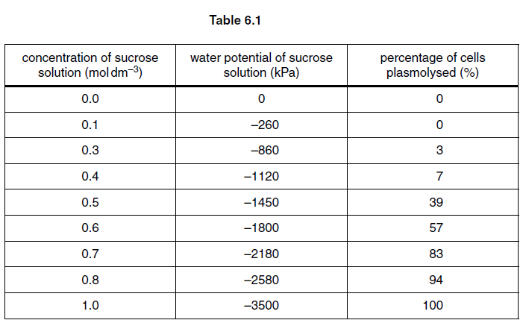

(b) None of the onion epidermis cells this student observed had burst when left in pure water.

Explain why plant cells do not burst when they are left in pure water.

_____________________________________________________________________________________________________

_____________________________________________________________________________________________________

_____________________________________________________________________________________________________

_____________________________________________________________________________________________________

[2]

(c) (i) The water potential of the onion epidermis cells can be assumed to be the same as the water potential of a solution that causes 50% plasmolysis.

Use the information in Table 6.1 to estimate the water potential inside these onion epidermis cells.

_____________________________________________________________________________________________________

[1]

(ii) Select data from the table to construct a graph on the next page in order to obtain a better estimate of the water potential inside the onion epidermis cells.

_____________________________________________________________________________________________________

_____________________________________________________________________________________________________

[6]

(d) Suggest how the student could modify the procedure to make the results more repeatable and accurate.

repeatable

_____________________________________________________________________________________________________

_____________________________________________________________________________________________________

_____________________________________________________________________________________________________

_____________________________________________________________________________________________________

_____________________________________________________________________________________________________

accurate

_____________________________________________________________________________________________________

_____________________________________________________________________________________________________

_____________________________________________________________________________________________________

_____________________________________________________________________________________________________

_____________________________________________________________________________________________________

[4]
[Total: 16]

Question: 2

Fig. 2.1 shows the structure of a plasma (cell surface) membrane.
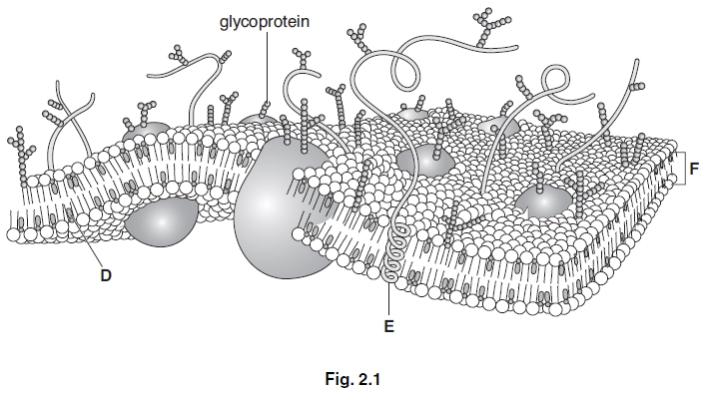

(a) (i) Name the components of the plasma (cell surface) membrane labelled D, E and F.

D ______________________________________________________________________

E ______________________________________________________________________

F ______________________________________________________________________
[3]

(ii) State one function for each of the components D, E and F.

D ______________________________________________________________________

E ______________________________________________________________________

F ______________________________________________________________________

[3]

(b) Glycoprotein molecules are positioned in the plasma (cell surface) membrane with the carbohydrate chain outside the cell.

This is to allow the glycoproteins to act as receptors in the process of cell signalling.

(i) Explain what is meant by the term cell signalling.

_____________________________________________________________________________________________________

_____________________________________________________________________________________________________

_____________________________________________________________________________________________________

_____________________________________________________________________________________________________

_____________________________________________________________________________________________________

_____________________________________________________________________________________________________

[2]

(ii) Explain how a glycoprotein can act as a receptor.

_____________________________________________________________________________________________________

_____________________________________________________________________________________________________

_____________________________________________________________________________________________________

_____________________________________________________________________________________________________

_____________________________________________________________________________________________________

_____________________________________________________________________________________________________

[2]

(c) A student investigated the effect of temperature on the release of pigment from pieces of beetroot. She cut a fresh beetroot into four pieces and placed each piece into water at a different temperature.

After 10 minutes she removed the beetroot and used a colorimeter to test how much pigment had entered the water. She placed the coloured water into the colorimeter and measured the percentage transmission of light through the water. Her results are shown in Table 2.1.
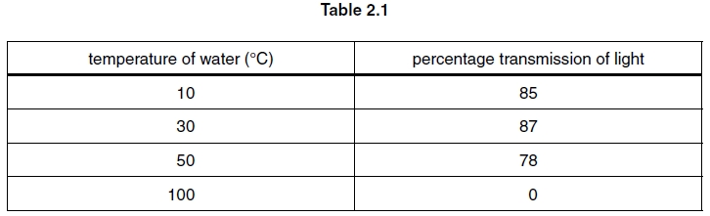

(i) The results show that below 50 °C little pigment had entered the water.

Explain why there was no transmission of light after the beetroot had been placed in water at 100 °C.

_____________________________________________________________________________________________________

_____________________________________________________________________________________________________

_____________________________________________________________________________________________________

_____________________________________________________________________________________________________

_____________________________________________________________________________________________________

[2]

(ii) Suggest three ways in which the student could have improved her investigation.

1

_____________________________________________________________________________________________________

_____________________________________________________________________________________________________

_____________________________________________________________________________________________________

2

_____________________________________________________________________________________________________

_____________________________________________________________________________________________________

_____________________________________________________________________________________________________

3

_____________________________________________________________________________________________________

_____________________________________________________________________________________________________

_____________________________________________________________________________________________________

[3]

[Total: 15]

Question: 3

Membranes are found both at the surface of cells and within cells.

(a) State two functions of membranes within cells.

_____________________________________________________________________________________________________

_____________________________________________________________________________________________________

_____________________________________________________________________________________________________

[2]

(b) Describe the arrangement and functions of two named components of a cell surface membrane.

In your answer you should use appropriate technical terms, spelled correctly.

_____________________________________________________________________________________________________

_____________________________________________________________________________________________________

_____________________________________________________________________________________________________

_____________________________________________________________________________________________________

_____________________________________________________________________________________________________

_____________________________________________________________________________________________________

_____________________________________________________________________________________________________

_____________________________________________________________________________________________________

_____________________________________________________________________________________________________

_____________________________________________________________________________________________________

_____________________________________________________________________________________________________

_____________________________________________________________________________________________________

_____________________________________________________________________________________________________

_____________________________________________________________________________________________________

_____________________________________________________________________________________________________

_____________________________________________________________________________________________________

_____________________________________________________________________________________________________

_____________________________________________________________________________________________________

_____________________________________________________________________________________________________

_____________________________________________________________________________________________________

[5]

(c) (i) Which component of a cell membrane becomes more fluid as temperature increases?

_____________________________________________________________________________________________________

[1]

(ii) Which component of a cell membrane denatures as temperature increases?

_____________________________________________________________________________________________________

[1]

(iii) Liver cells contain membrane-bound organelles called peroxisomes. These organelles contain catalase, an enzyme that breaks down hydrogen peroxide to release oxygen gas.

A student carried out an investigation on catalase using the following procedure:

• two identical sized cubes were cut from a piece of fresh liver

• one cube was frozen overnight and then defrosted

• the other cube was stored in the refrigerator

• both cubes were returned to room temperature and were placed in separate test tubes containing equal volumes of 2% hydrogen peroxide solution.

The student observed that the cube of liver that had been frozen and defrosted, bubbled significantly more than the cube that had been refrigerated.

Suggest an explanation for this result.

_____________________________________________________________________________________________________

_____________________________________________________________________________________________________

_____________________________________________________________________________________________________

_____________________________________________________________________________________________________

_____________________________________________________________________________________________________

[2]

[Total: 11]

