AS-Level Biology
Revision Pack
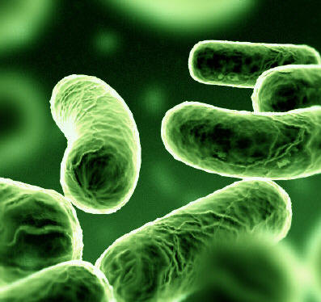

Unit 1: Biology & Disease

Name:___________________ Teacher:___________________

Section 1.1: Causes of Disease - Pathogens

- Health – A state of physical and mental well-being, free from disease.

- Disease – An abnormal condition of an organism that impairs bodily functions and is associated with specific symptoms.

- Non-infectious – Sometimes called disorders and can be caused by a broad range of environmental factors. They cannot be transferred.

- Infectious – Caused by pathogens. Can be passed on.
- Inherited – due to a mistake or alternation in the genetic make-up e.g. Down’s syndrome, cystic fibrosis, Huntington’s disease etc.
- Nutritional deficiency – caused by inadequate or unbalanced diet or by over-eating E.g. scurvy, obesity, rickets, etc.
- Psychological disorders – diseases causing changes in the working of the brain E.g. schizophrenia.
- Social/self induced – Influenced by living conditions or personal behaviour e.g. lung cancer, STIs, etc.
- Degenerate – wholly/partly caused by aging. Organs and tissue may not work as well due to slower cell renewal and repair.
- Environmental – Abnormal bodily reaction caused by the environment e.g. U.V rays.
Note: many diseases can be caused by multiple factors.

Most microbes are harmless.
Pathogen – disease causing microbe.
Infection – process by which a pathogen enters and establishes itself.

- Communicable disease – spread via close proximity or contact.

- Non-Communicable – disease caused by food/drink or animal vectors e.g. mosquitoes.

- Interface – where internal and an external environment meet.

- Skin – Difficult to penetrate, thick and water proof. Platelets quickly produce scabs.

Interfaces are adapted for absorption but also make it easier for pathogens to pass through.
Gas exchange – airborne pathogens

Digestive System – Disease in contaminated food or water.

Defences

Gas exchange – thick/sticky mucus traps pathogens. Celia on the surface of epithelial cells work together to remove microbes.

Digestive system – concentrated HCl kills microbes. Protease also kills microbes.

Fungi – Opportunistic pathogens. Fungal toxins are called mycotoxins.

Viruses – Invade body cells in order to reproduce thus preventing the host cell functioning as normal. It kills body cells and rarely produces toxins.

Bacteria reproduction is called binary fusion.

Endemic – a disease that is always present in the population.

Epidemic – when a new disease spreads rapidly through the population.

Pandemic – when an outbreak occurs on a global basic.

Section 1.2: Epidemiology

Epidemiology is the study of patterns in diseases and the various factors that affect the spread of disease.

A correlation is different causal link.

Strong, positive correlation

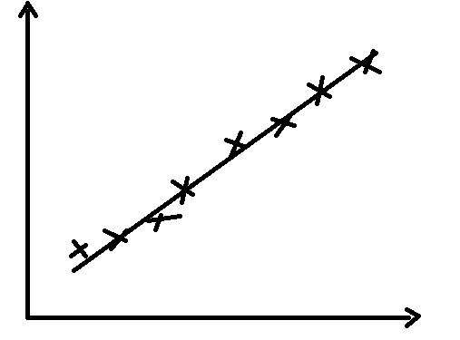
A positive correlation will occur when an increase in one variable, causes an increase in another. In order for the correlation to be “strong”, there must be little spread in the data.

Weak correlation

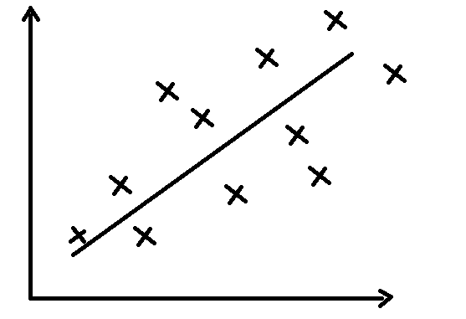
A weak correlation occurs when there is a wide spread of data shown in the graph.

Negative Correlation

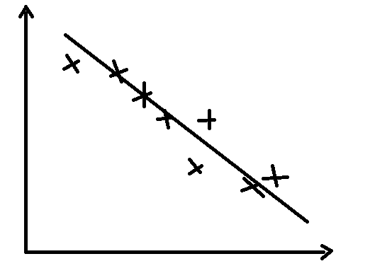
A negative correlation will occur when an increase in one variable causes a decrease in another.

How to prove a link

- Wide samples must be used.

- Data must be analysed over long periods of time.

- Variables must be controlled.

Demographic Transition

Explains how the population changes over time e.g. from high birth rate.

Section 1.3: Lifestyle and Health

- Risk – A measure of probability that damage to health will occur as a result of a given hazard.

- We need to look at probability that a hazard will occur as a consequence of the hazardous event.

- If the consequence of the hazard is high and the probability is low, there is little cause for concern.

- A major concern is when both are high.

Measuring risk

- 0% (no harm will occur)
- 100% (will definitely occur)

- A timescale is needed to give the data more weight.

- Risk must be relative.

Cancer

- Cancer – Cell division in an uncontrollable fashion. This continues if there are nutrients.

- Cancer cells cease to function normally.

- Carcinogen – Cause the DNA to mutate. They are cancer causing agents.

- Most mutated cells are destroyed.

- One mutated cell can cause a mass of mutated cells.

- Benign – does not move from the point of origin. Usually harmless, however can cause problems depending on where it grows.

- Maligment – grow faster and can spread throughout the body. Can have its own blood supply. The process of moving to another area of the body is called metastasis.

- Older people = more likely.

- Genetics can cause approximately 5% of cancers. Tumour producing genes (oncogenes).

- Lifestyle factors can expose you to more carcinogens.

- More you smoke, higher the risk.

- Diet – low fat, high fibre, fruit etc.

- Radiation, UV light and X-rays are carcinogens.

- Physical activity – exercise reduces the risk.

- Alcohol – increases risk.

- Hormones – high level of sex hormones can increase risk.

Treatments

- Prevention is better than cure.

- Early diagnosis.

- Surgical removal – Easiest when the tumour is benign.

- Chemotherapy – using drugs to kill cells in the body. Affects all cells that divide rapidly.

- Radiotherapy – ionising radiation that destroys tissue. Healthy cells suffer less so there are little side-effects.

Future treatments

- Hyperthermia may destroy cancer because the immune system is better at detecting cancer cells.

- It may be possible to create drugs which can locate genes which are responsible for mutating and causing each type of cancer.

Smoking

- Heavy smoking over a long period of time will drastically increase the risk of developing lung cancer.

- There is a strong correlation, but not a causal link.

Conclusive evidence

- Tar in cigarettes contains Benzopyrene (carcinogen)

- Cancer cells were looked at and scientist found that mutations occurred in 3 places in the DNA.
- The gene that mutates is called a tumour suppressor gene.

- This is still not a causal link because smoking does not definitely cause cancer, even though it is very likely to be the cause.

- It is only a correlation because it is a multi-factorial disease.

Coronary Heart Disease

- Largest cause of death in the U.K

- Occurs when one of the arteries supplying heart tissue with oxygen is blocked.

- Heart cells respire anaerobically when there is a blood clot.

- Anaerobic respiration does not release enough energy.

- Heart attack – myocardial infarction.

- Blood clot – thrombus

- Process of a blood clot forming is called thrombosis.

- If this happens to coronary arteries it is called coronary thrombosis.

- Smoking narrows blood vessels thus increase blood pressure.

- High blood pressure increases the rate at which cholesterol is deposited.

- Exercise can lower blood pressure.

- Diets high in saturated fats will increase the risk of developing coronary heart disease.

Section 2.1: Enzymes and Digestion

- Glands produce enzymes that are used to break down large molecules into smaller ones that are ready for abortion.

- The digestive system provides an interface between the body and the environment because it allows food to pass through it.

Major parts of the digestive system

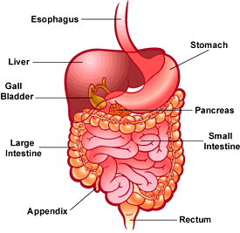

- The Oesophagus is made up of a thick muscular wall and is adapted so that food can pass down it easily from the mouth to the stomach. Therefore it used for transport, as appose to digestion.

- The stomach is a muscular sac with an inner layer that produces enzymes. Its roles are to store and digest food (especially proteins). There are glands within it that produce enzymes to digest protein. Mucus is also produced in the stomach by glands. The mucus prevents the stomach being digested by its own enzymes.

- The small intestine is a long muscular tube. Food is further digested by enzymes in the small intestine. The enzymes enter the small intestine through its walls and through glands. The inner walls of the small intestine are folded into villi, giving them a larger surface area. The surface area of villi is further increased by millions of tinier projections called microvilli. The microvilli are found on the epithelial cells of each villus. This adapts the small intestine so that it can absorb substances into the blood stream.

- The large intestine absorbs water. Often the water is reabsorbed by the secretion of digestive glands. Because there is little water within the large intestine, the food becomes drier, thus forming faeces.

- The rectum is where faeces are stored before it is removed through the anus in a process called egestion.

- The salivary glands are positioned near the mouth. They pass there secretion via a duct into the mouth. This secretion will contain the enzyme amylase.

- The pancreas is a large gland situated near the stomach. It secretes pancreatic juice. This contains protease, lipase and amylase.

There are two stages of digestion; physical breakdown and chemical absorption.

Physical breakdown

Large pieces of food are broken down into smaller pieces by processes such as chewing and the churning of food in the stomach. This makes it possible to not only absorb food but to increase its surface area, thus making it easier for chemical absorption.

Chemical digestion

Chemical digestion is the process of breaking down large molecules into smaller ones so that they can be absorbed. This is carried out by enzymes. Enzymes function by hydrolysis. Hydrolysis is the process of splitting up molecules by adding water to the bonds that hold them together. The general term for these enzymes is hydrolases. Because enzymes are specific, more than one is needed to break down a large molecule. Usually, an enzyme will break down a molecule into smaller sections. These smaller sections are then hydrolysed into even smaller molecules by additional enzymes.

Carbohydrases break starch molecules down until they become monosaccharides.
Lipase breaks down lips into glycerol and fatty acids.
Protease breaks protein down to amino acids.

Once these molecules have been broken down to become even smaller molecules such as monosaccharides, they are absorbed into the body and are often built up again to form larger molecules again. These new molecules are incorporated into body tissue or are used in processes within the body. This is called assimilation.

Section 2.2: Carbohydrates – Monosaccharides

- Carbohydrates are carbon molecules (carbo) combined with water molecules (hydrate).

Life based on Carbon

- Carbon atoms are able to readily form bonds with other carbon atoms

- Life on earth is based on the versatile carbon atom.

The making of large molecules

- Carbohydrates are long chains made up of individual molecules called monosaccharides.

- A pair of monosaccharides is called a disaccharide and several monosaccharides joined together are called a polysaccharide.

Monosaccharides

- Monosaccharides are soluble and have the general formula (CH20)n. N can be any number from 3 -7.

- Glucose is a hexose because it has 6 carbon atoms and has the formula C6H12O6

- Even though it has the same chemical formula, the hydrogen and oxygen atoms can be arranged in many different ways:

Glucose
Galactose
Fructose

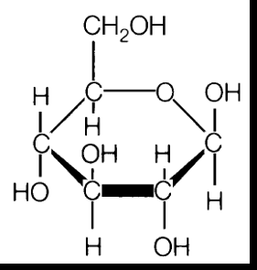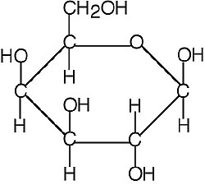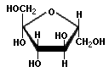
Glucose is the most common sugar. Although its molecular arrangement is often shown as a straight line, its atoms form a ring.
Galactose has the same chemical formula as glucose. However on the left of the diagram you can see how the Hydroxide and hydrogen atoms are arranged differently to glucose.
Fructose has a very different structure to glucose and is often used as a sweetener.

Section 2.3: Carbohydrates – disaccharides and polysaccharides.

Disaccharides

When combined in pairs, monosaccharides form disaccharides.

- Glucose with glucose forms maltose
- Glucose with fructose forms sucrose
- Glucose linked with Galactose forms lactose.

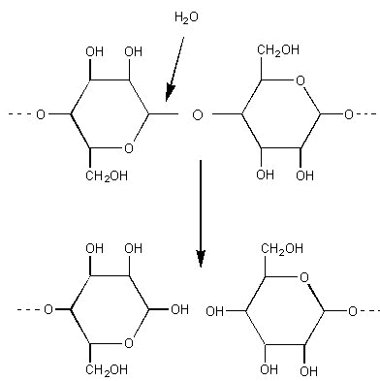
- When two monosaccharides join together, a water molecule is removed. This is called a condensation reaction.

- In order to break the bond, water is added to the molecule in a process called hydrolysis.

- The bond holding the two monomers together is called a glycosidic bond.

- A glycosidic bond involves an oxygen atom.

Polysaccharides

- Polysaccharides are long chains of monosaccharides combined together through glycosidic bonds.

- Because they are very long molecules, they are often insoluble. This means that they are very suitable for storage.

- When hydrolysed, polysaccharides break down into disaccharides or monosaccharides.

- Some polysaccharides such as starch are not used for storage, but instead are used to give support to plant cells.

Test for non-reducing sugars

To test for a non reducing sugar it must first be hydrolysed then added to Benedict’s reagent.

Test for starch

To test for starch, add potassium iodine solution. If starch is present, the iodine will turn from yellow to blue-black.

Section 2.4 – Carbohydrate digestion

- It usually takes more than one enzyme to break down a large molecule.

- Food is physically broken down by teeth to increase surface area.

- Normally one enzyme breaks a large molecule into smaller sections, and then other enzymes break these down to monomers.

- Firstly the enzyme “amylase” is produced in the mouth by salivary glands, where the pH is kept at neutral by mineral salts.

- This enzyme breaks starch into maltose by hydrolysing the glycosidic bonds holding the molecule together.

- Once the food is swallowed, the enzyme is destroyed by the stomach acid where the pH is around 2. This means that no more starch can be digested.

- After the stomach, food passes into the small intestine where it mixes with pancreatic juices.
- The pancreatic juice contains pancreatic amylase which hydrolyses the remaining starch.

- Alkaline salts are produced by the intestine wall and the pancreas to maintain the pH at neutral so that the enzymes can work efficiently.

- The epithelial lining of the intestine produces the enzyme maltase. This breaks maltose into glucose.

- Sucrase which is produced by the epithelial lining breaks down sucrose into fructose and glucose.

- People who are lactose intolerant do not produce enough lactase to break down the lactose found in milk.

- When undigested lactose enters the small intestine, bacteria digest it and produce lots of gas.

- This can cause stomach cramps, nausea and diarrhoea.

- For new born babies, milk makes up the majority of their diet. To overcome the problem of lactose intolerance amongst children, lactose can be pre-digested before consumption.

Section 2.5 – Proteins

- Each organism has numerous proteins that differ from species to species.

- The structure of one protein molecule differs from that of all other protein molecules.

- Proteins are the most important molecules for life.

Structure of amino acids

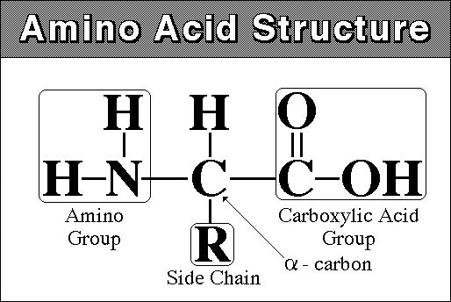
There are 4 main parts that make up the general structure of an amino acid. There is:

The amino group (NH2) this is a basic part of the molecule where it gets the name amino.
The carboxyl group (COOH) this is an acid group.
The hydrogen atom (H)
The r group, this can be a variety of chemicals. Each amino acid has a different r group.

The formation of a peptide bond

Through the same process by which monosaccharides join to make disaccharides and polysaccharides, amino acids can join together to form dipeptides.

They create a water molecule by combining the OH from the carboxyl group of one amino acid with the hydrogen atom of another amino acid.

When there is a repeating sequence of amino acids joined by a peptide bond, it is called a polypeptide chain.

Primary Structure

After many condensation reactions (removal of water molecules to form a peptide bond), many monomers are joined together in a process called polymerisation.

The chain of many amino acids is called a polypeptide.

This repeating sequence of amino acids in a polypeptide chain is known as the primary structure.
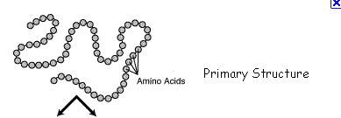

Secondary structure

The secondary structure is formed when the -C=O (which has an overall negative charge) is attracted to the hydrogen atom (which has an overall positive charge).
This causes the long chain to twist in on its self creating a coil known as an alpha helix.

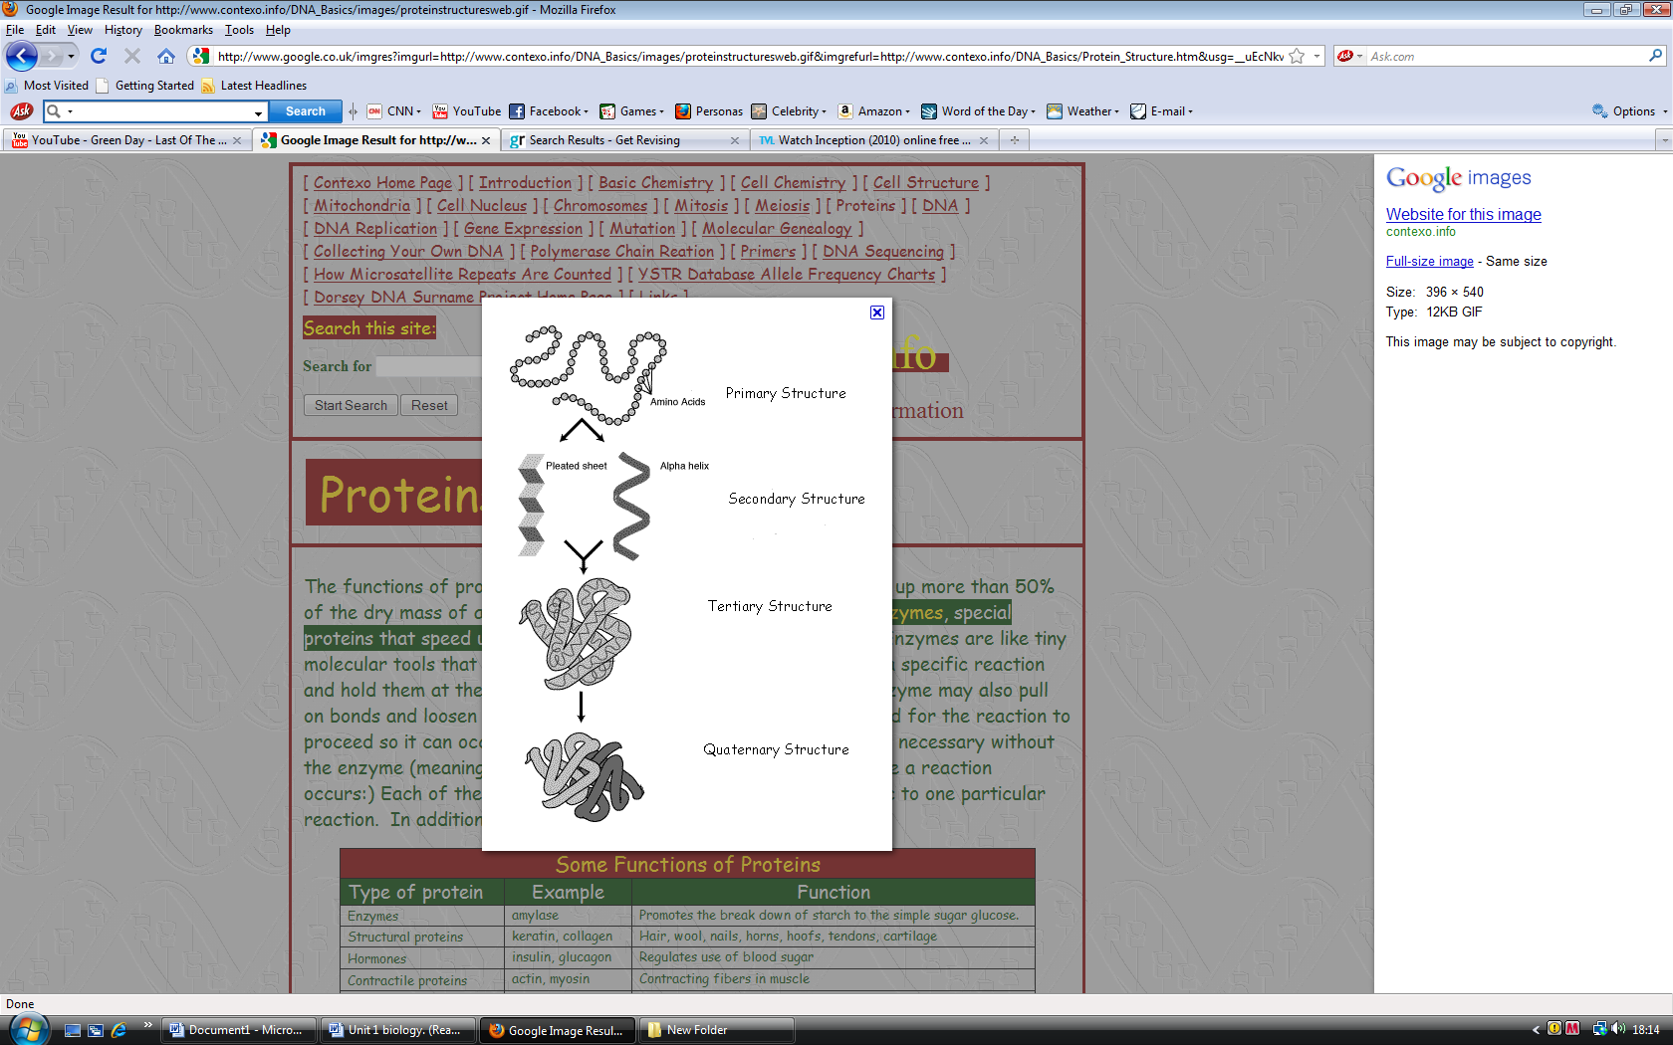

Tertiary Structure

The secondary structure, which is an alpha helix can be further twisted and folded forming a unique 3D structure for each protein.

It is formed by several different types of bonds.

Disulphide bond – fairly strong, not easily broken down.

Ionic bonds – formed by the carboxyl and amino groups. They are weaker than disulphide bonds. A change in pH can affect an ionic bond.

Hydrogen bonds – there are many of these however they are easily broken down.

Quaternary Structure

This structure appears when a number of complex molecules containing polypeptide chains that are linked in various ways are associated with non-protein molecules called prosthetic groups.

Section 2.6 – Enzyme action

- All enzymes are globular proteins → spherical in shape

- Control biochemical reactions in cells

- They have the suffix "-ase"

- Intracellular enzymes are found inside the cell

- Extracellular enzymes act outside the cell

- Enzymes are catalysts → speed up chemical reactions
- Reduce activation energy required to start a reaction between molecules
- Substrates (reactants) are converted into products
- Reaction may not take place in absence of enzymes (each enzyme has a specific catalytic action)
- Enzymes catalyse a reaction at maximum rate at an optimum state.
- The substrate and the enzyme must collide with sufficient energy.
- Enzymes work by lowering the activation energy required to start a reaction.
- Once the substrate is inside the active site, the enzyme changes shape slightly, distorting the molecule in the active site, and making it more likely to change into the product.
- It's a bit more complicated than that though. Although enzymes can change the speed of a chemical reaction, they cannot change its direction, otherwise they could make "impossible" reactions happen and break the laws of thermodynamics.
- When a substrate (or product) molecule binds, the active site changes shape and fits itself around the molecule, distorting it into forming the transition state, and so speeding up the reaction. This is sometimes called the induced fit mechanism.

Section 2.7 – Factors affecting enzyme action

Measuring enzyme-catalysed reactions

- To measure the progress of an enzyme-catalysed reaction, its time course is measured. This is how long it takes to run its course.

- The two “events” most frequently measured are the volume of gas produced during a reaction and the disappearance of a substrate.

Effect of Temperature

- Enzymes have an optimum temperature at which they work fastest. For mammalian enzymes this is about 40°C, but there are enzymes that work best at very different temperatures, e.g. enzymes from the arctic snow flea work at -10°C, and enzymes from thermophilic bacteria work at 90°C.

- The rate of reaction doubles, approximately almost every ten degrees.

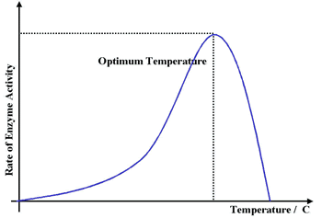
- The rate of reaction will increase as temperature increases. Then, once it reaches its optimum temperature it will begin to decrease as the temperature rises due to the active site being denatured.

- The thermal energy breaks the hydrogen bonds holding the secondary and tertiary structure of the enzyme together, so the enzyme (and especially the active site) loses its shape to become a random coil.

Effect of pH

- Enzymes have an optimum pH at which they work fastest.

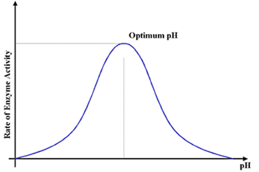
- For most enzymes this is about pH 7-8 (physiological pH of most cells), but a few enzymes can work at extreme pH, such as protease enzymes in animal stomachs, which have an optimum of pH 1.

- The pH affects the charge of the amino acids at the active site, so the properties of the active site change and the substrate can no longer bind. For example a carboxyl acid R groups will be uncharged a low pH (COOH), but charged at high pH (COO⁻).

Section 2.8 – Enzyme inhabitation

Inhibitors inhibit the activity of enzymes, reducing the rate of reactions. They are found naturally, but are also used artificially as drugs, pesticides and research tools. There are two kinds of inhibitors.

Competitive inhibitor

- A competitive inhibitor molecule has a similar structure to the normal substrate molecule, and it can fit into the active site of the enzyme.
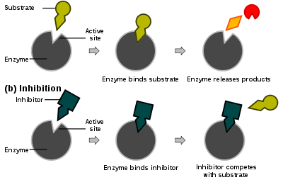
- It therefore competes with the substrate for the active site, so the reaction is slower.

- It is the difference between the concentration of the inhibitor and the concentration of the substrate that determines the affect it has on the enzymes activity.

- The inhibitor is not permanently bonded to the active site so once it leaves a substrate molecule can take its place.

- Eventually all the substrate molecules will be in the active sites. However, depending on the concentration of the inhibitor, the longer this will take.

Non-competitive inhibitors

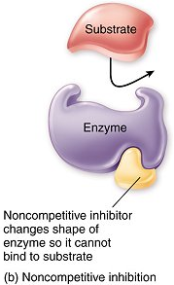
- Non-competitive inhibitors do not fit into the active site but instead they bind to another part of the enzyme molecule, changing the shape of the whole enzyme, including the active site, so that it can no longer bind substrate molecules.

- Inhibitors that bind fairly weakly and can be washed out are sometimes called reversible inhibitors, while those that bind tightly and cannot be washed out are called irreversible inhibitors. Poisons like cyanide, heavy metal ions and some insecticides are all non-competitive inhibitors.

- Non-competitive inhibitors therefore simply reduce the amount of active enzyme (just like decreasing the enzyme concentration).

Section 3.1 – Investigating the structure of cells

Microscopy

Lenses work more effectively if they are in a compound light microscope.

Light waves a have a relatively long wavelength; therefore, they can only distinguish between objects that are at least 0.2 micrometers apart.

Beams of electrons have shorter wavelengths and are therefore able to distinguish between objects as close as 0.1 nm apart.

Magnification

When viewed under a microscope, the material seen in called an image.

Magnification tells you how many times bigger the image is in relation to the actual size of the object. It can be found using the following formula:
Magnification = size of image/size of object

The previous formula can also be rearranged to find the size of an object.
Size of object = size of image/magnification

Resolution

The resolving power of a microscope is the minimum distance two objects can be apart in order for them to appear as separate items.

The greater the resolution, the greater the clarity of the image that is produced.

Cell fractionation

Cell fractionation is the process where cells are broken up and the different organelles they contain are separated out.

Before fractionation begins, the cells are put in a solution that is:

Cold – to reduce enzyme activity that might break down the organelles.
Isotonic – to prevent organelles bursting or shrinking as a result of osmotic gain or loss of water. An isotonic solution is one that has the same water potential as the original tissue.
Buffered – to maintain a constant pH.

Homogenation

Cells are broken up by a homogeniser that releases the organelles. The fluid is called a homogenate. It is then filtered to remove complete cells and large pieces of debris.
Ultracentrifugation

Ultracentrifugation is the process by which the homogenate is separated in a machine called a centrifuge.

This spins tubes of the homogenate, creating a centrifugal force that makes the mixture separate.

- The tube of filtrate is placed in the ultracentrifuge and spun at a slow speed.
- The heaviest organelles such as the nucleus are forced to the bottom where they form a thin sediment.
- The fluid at the top, called the supernatant is removed, leaving just the sediment of nuclei at the bottom.
- The supernatant is then put in another tube where it is spun at an even higher speed than before.
- The next heaviest organelles (mitochondria) are forced to the bottom and the process continues until all the organelles are separated.

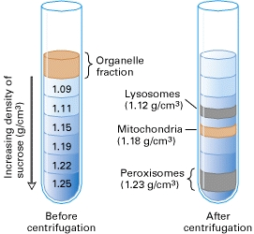

Section 3.2 – The electron microscope

Electrons have a shorter wavelength than light and so they have a greater resolving power.

As electrons are negatively charged, the beam can be focused using an electromagnet.

Because electrons are absorbed by molecules in the air, a near vacuum must be created within the chamber of an electron microscope for it to work effectively.

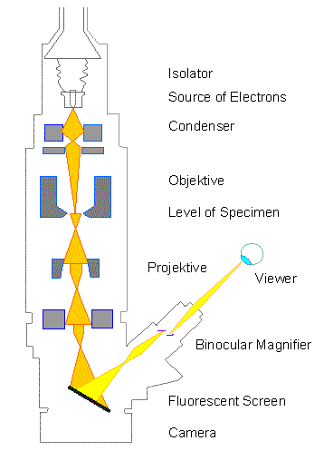
There are two types of electron microscope:

- Transmission electron microscope and scanning electron microscope.

Transmission electron microscope

The TEM consists of a gun that fires electrons which are focused onto the specimen by an electromagnet.

Some of the electrons are absorbed by the specimen and appear dark on the image; other parts allow the electrons through and so appear light. This produces an image of the specimen.

The image that appears on screen is called a photomicrograph.

Because the process takes place in a vacuum, living specimens cannot be observed.
A complex staining process is required and even then the image is only in B&W.
The specimen must be extremely thin.
Artefacts (structure not present in the organism when it was alive) may appear on the image, these appear as a result of the way the specimen is prepared.

Scanning electron microscope

All the limitations of the TEM apply to the SEM but the specimen does not have to be extremely thin as the electrons do not penetrate.
The beam of electrons is directed over the surface of the specimen in a regular pattern.

The electrons bounce on the contours of the specimen and are scattered.
The scattering of the electrons can be analysed and from this an image can be produced using a computer.
The SEM has a lower resolving power than the TEM (20nm) but is still ten times better than a light microscope.

Section 3.3 – Structure of epithelial cells

Epithelial cells are eukaryotic cells. Eukaryotic cells have a distinct nucleus and a membrane that surrounds each organelle.
The function of an epithelial cells is to absorb and secrete.

The nucleus

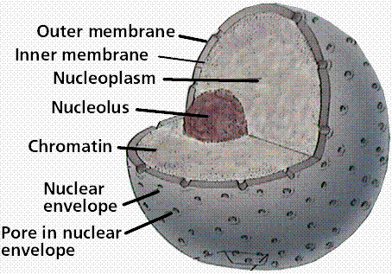
The nucleus controls the cells activities and contains hereditary material.

- The Nuclear envelope is a double membrane that surrounds the nucleus. Its outer membrane is continuous with the endoplasmic reticulum and often has ribosomes on its surface. It can control the substances entering and leaving the nucleus.

- Nuclear pores allow the passage of large materials into and out of the nucleus.

- Nucleoplasm is granular jelly like material that makes up the bulk of the nucleus.

- Chromatin is the DNA found within the nucleoplasm This is the diffuse form chromosomes take up when the cells is not dividing.

- The nucleolus is small spherical body within the nucleoplasm. It manufactures ribosomal RNA and assembles ribosomes.

The mitochondria

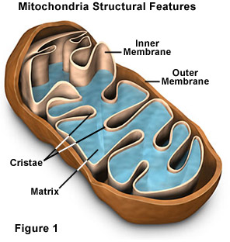
- A double membrane surrounds the organelle, the outer one controlling the entry and exit of material. The inner membrane inner membrane is folded to form extensions known as cristae.

- Cristae are shelf like extensions of the inner membrane. These provide a large surface area for the attachment of enzymes during respiration.

- The matrix makes up the remainder of the mitochondria. It is a semi-rigid material that contains proteins, lipids and traces of DNA that allows the mitochondria to control the production of its own proteins. The enzymes involved in respiration are found in the matrix.

Mitochondria are responsible for the production of the energy-carrier molecule ATP. Because of this, high numbers of mitochondria are found in cells where there is a high level of metabolic activity.

Endoplasmic Reticulum

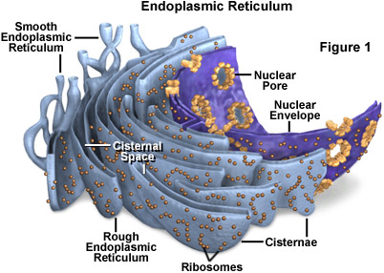
Rough endoplasmic reticulum – has ribosomes present on the outer surface of the membranes. Its functions are to: a) provide a large surface area for the synthesis of proteins and glycoproteins, b) provide a pathway for the transport of materials, especially proteins throughout the cell.

Smooth endoplasmic reticulum - lacks ribosomes on its surface and is often more tubular in appearance. Its functions are to: a) synthesise, store and transport lipids, b) synthesise store and transport carbohydrates.

Golgi Apparatus

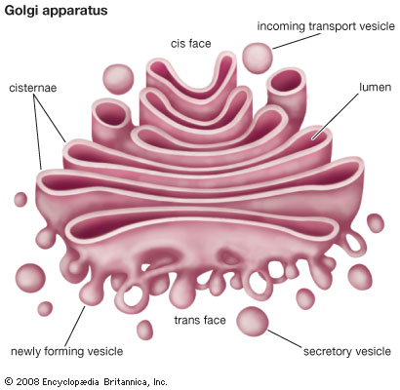
The Golgi apparatus is similar to the SER in structure but is more compact.

It consists of a stack of membranes that form flattened sacks, or cisternae with small rounded hollow structures called vesicles.

The proteins and lipids produced in the ER are passed through the Golgi apparatus in strict sequence.

The Golgi apparatus modifies these proteins often by adding non-protein structures to them such as carbohydrates. It is also labels them so they can be sorted and sent to their correct destination. Once sorted and modified, proteins are transported in vesicles which are regularly removed from the edge of the Golgi cisternae.

These vesicles move to the cell membrane where they fuse and release their contents to the outside (exocytosis).

Lysosomes

Lysosomes are formed when a vesicle contains enzymes.
Lysosomes isolate potentially dangerous enzymes from the rest of the cell before releasing them outside of the cell or into phagocytic vesicles within the cell.

Lysosomes digest worn out organelles so that the useful chemicals they are made of can be reused.

They can completely break down cells after they have died. (Apoptosis)

Ribosomes

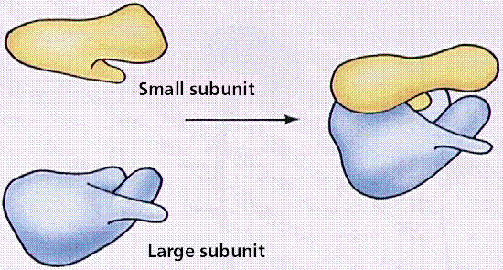
Ribosomes occur in either the cytoplasm or the RER. There are two types depending on which cell they are found in:
80S Type – found in eukaryotic cells, is around 25nm in diameter.
70S Type – found in prokaryotic cells, is slightly smaller.

Microvilli

Microvilli are finger like projections of the epithelial cells. Their function is to increase the surface area for diffusion.

Section 3.4 - Lipids

- Lips contain carbon, hydrogen and oxygen.
- The proportion of oxygen to carbon and hydrogen is smaller than in carbohydrates.
- They are insoluble in water.
- They are soluble in organic solvents such as alcohol and acetone.

Roles of lipids

Phospholipids contribute to the flexibility of membranes and the transfer of lipid-soluble substances across them. In addition to this, lipids can be used as:
An energy source. Lipids can provide more than twice the energy of carbohydrate.

Waterproofing. Lipids are insoluble in water and are therefore suitable for waterproofing.

Insulation. Fats are slow conductors of heat, kept under skin to retain heat in the body.

Protection. Often stored around delicate organs.

Triglycerides are so called because they have three fatty acids (tri-) combined with glycerol (-glyceride).

Each fatty acids combines with glycerol in a condensation reaction.

CH2OH + HOOC → CH2OOC + H2O
(Glycerol) + (fatty acid)

Phospholipids

Phospholipids are similar to lipids except that the fatty acid is replaced with a phosphate molecule.

Fatty acid molecules repel water whereas phosphate molecules are attracted to water.

Test for lipids

- Take a dry, grease free test tube.

- Take 2cm³ of the sample being tested and add 5cm³ of ethanol.

- Shake the test tube and dissolve the lipids.

- Add 5cm³ of water and shake gently.

- A cloudy white colour indicates the presence of a lipid.

Section 3.5 – The cell surface membrane

The cell-surface membrane is a plasma membrane that surrounds cells and forms a boundary between the cytoplasm and the environment.

Phospholipids

Phospholipids are important in cell surface membranes because:

- One layer of phospholipids has its hydrophilic head pointing inwards towards the water in the cytoplasm. The other has its head pointing outwards, interacting with the water surrounding the cell.
- The hydrophobic tales point inwards.

The function of phospholipids in the cell-membrane are to:
Allow lipid-soluble substances to enter and leave the cell,
Prevent water-soluble substances entering and leaving the cell,
Make the membrane more flexible.

Proteins

The proteins in the phospholipids bilayer are arranged randomly in two main ways:

Extrinsic proteins – appear on the surface or partially imbedded. They provide mechanical support or when in conjunction with glycolipids, act as cell receptors for molecules such as hormones.

Intrinsic proteins – Span the phospholipids bilayer. Some transport water soluble molecules across the membrane others are enzymes.

Protein molecules in the membrane allow active transport by forming ion channels for sodium, potassium, etc.

Fluid-mosaic model of the cell surface membrane

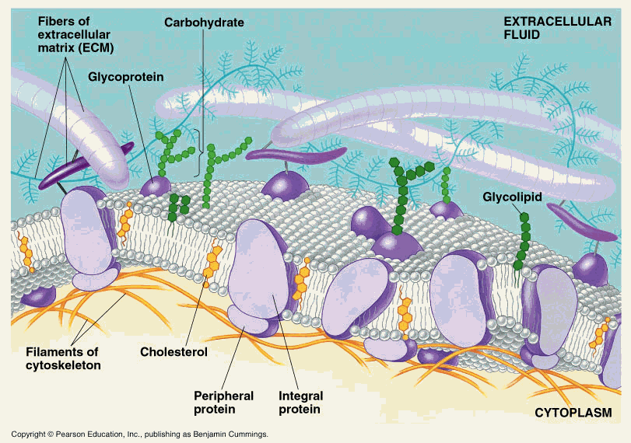
Fluid - because the phospholipids molecules can move relative to each other, giving it a flexible structure.

Mosaic – because the proteins are imbedded in the structure in a similar way that stones are imbedded in a mosaic.

Section 3.6 - Diffusion

Diffusion is defined as the net movement of molecules or ions from a region where they are more highly concentrated to one where their concentration is lower.

All particles are constantly in motion due to the kinetic energy that they posses.

The motion is random and there is no set pattern to the way they move.

Rate of diffusion

- The greater the difference in concentration, the greater the rate of diffusion

- The larger the area of an exchange surface, the greater the rate of diffusion.

- The thinner the exchange surface, the faster the rate of diffusion.

- The nature of the plasma membrane; its composition and the number of pores.

- The size and nature of the diffusing molecule. For example smaller molecules diffuse faster than big ones.

Diffusion is proportional to: surface area x difference in concentration
Length of diffusion path

Facilitated diffusion

Facilitated is a passive process as it only relies on the kinetic motion of particles.

Facilitated diffusion can only occur at specific point along the plasma membrane where there are special protein molecules.

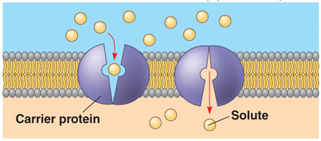
The proteins for special water filled channels.

The channels only open for specific molecules.

This allows water soluble ions and molecules to pass through. Such molecules such as glucose and amino acids would take much longer to diffuse through the phospholipids bilayer.

When a molecule that is specific to the carrier protein is present, the carrier protein changes shape, causing it to release the molecule on the other side of the plasma membrane.

Section 3.7 – Osmosis

Osmosis is defined as the passage of water from a region where it has a higher water potential to a region where it has a lower water potential through a partially permeable membrane.

Water potential is measured in Pascal’s.

Under standard conditions of temperature (25ºC), pure water is said to have a water potential of 0.

Water with a solute dissolved in it will have a water potential that is less than 0.

Water molecules move from one side where the water potential is higher (less negative) across a partially permeable membrane to another side where the water potential is lower (more negative).

The water moves along a water potential gradient.

At the point where the water potentials on either side of a partially permeable membrane are equal, a dynamic equilibrium is established and there is no net movement of water.

Osmosis in animal cells

If a red blood cell is place in pure water it will absorb water by osmosis because it has a lower water potential.

The cell-surface membrane will eventually burst if too much water enters the cells.

To prevent cells bursting due to too much water entering the cells, cells are often bathed in solutions where the water potential outside the cell is the same as the water potential inside the cell. This is called an isotonic solution.

A hypotonic solution is one where the concentration outside is greater than the concentration inside.

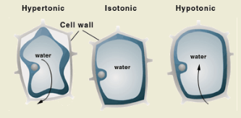
A hypertonic solution is one where the water potential outside the cell is lower than the water potential inside the cell.

Section 3.8 – Active transport

Active transport allows cells to exchange molecules against a concentration gradient.

Metabolic energy is required for this process.

Active transport is the movement of molecules or ions into or out of a cell from a region of lower concentration to a region on higher concentration using energy and carrier molecules.

Metabolic energy is needed in the form ATP.

Carrier molecules which act as “pumps” are involved.

- Active transport uses ATP in two main ways:
by using ATP to directly move molecules.

- By using a concentration gradient that has already been set up by direct active transport. This is known as co-transport.

- The carrier molecules accept molecules or ions to be transport on one side of it.

- The molecules of the ions bind to the receptors on the channels of the carrier protein.

- On the other side of the membrane ATP bind to the carrier protein causing it to split into ADP and a phosphate molecule. This as a result, causes the carrier protein to change shape, releasing the molecule onto the other side.

- The phosphate molecule then recombines with the ADP to form ATP again, which causes the carrier protein to revert back to its original shape.

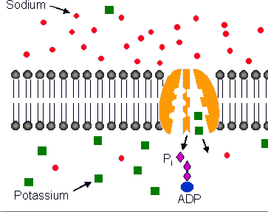
Occasionally, the molecule or ion is moved into the cell at the same time as a different one is being removed from it. One example of this is the sodium-potassium pump

Sodium ions are actively taken in by the cell whilst potassium ones are actively removed from the cell.

Section 3.9 – Absorption in the small intestine

Villi and Microvilli

Villi have walls lined with epithelial cells.

Villi are situated at the interface between the lumen of the intestines and the blood and other tissues inside the body.

Their properties increase the efficiency of absorption because:

- They increase the surface area for diffusion

- They are very thin walled, thus reducing the distance over which diffusion takes place.

- They are able to move and so maintain a concentration gradient

- They are well supplied with blood vessels so that the blood can carry away absorbed molecules and hence maintain a diffusion gradient.

The epithelial cells possess Microvilli which further increase the surface area for diffusion. They are situated on the cell surface membrane.

Villi contain muscles which move the food ensuring the glucose is absorbed from the food adjacent to the villi, new glucose rich food replaces it, thus maintains a concentration gradient for diffusion.

Role of active transport in absorption

The way in which most glucose is absorbed from small intestine is an example of co-transport.

- Sodium ions are actively transported out of the epithelial cells by the sodium potassium pump.

- There is now a much higher concentration of sodium ions in the lumen than in the cells.

- The sodium ions diffuse into the cells down a concentration gradient. As they flood back into the cells, they are coupled with glucose molecules which are drawn in with them.

- The glucose diffuses into the blood through a carrier protein.

It is the sodium ion concentration, rather than the ATP directly, that powers the movement of glucose into the cell.

Section 3.10 – Cholera

Structure of a bacteria cell

The bacterium that causes cholera is called Vibrio Cholerae.

- All bacteria possess a cells wall that is made up of peptidoglycan. This is a mixture of polysaccharides and peptides.

- Many bacteria also protect themselves by producing a capsule of mucilaginous slime around this wall.
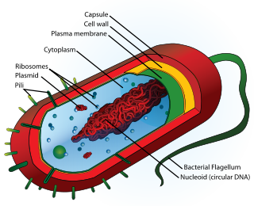
- Flagella occur at certain types of bacteria.

- Inside the cell-surface membrane is the cytoplasm that contains ribosomes that are smaller than the ones found in eukaryotic cells. (70s type)

- Bacteria store food as glycogen granules and oil droplets.

- The genetic material of a bacterium is found in the form of a circular strand of DNA.

- Separate from this are smaller circular pieces of DNA, called plasmids.

How the cholera bacterium causes disease

Almost all Vibrio cholerae bacteria ingested by humans are killed by the low pH in the stomach but many can still survive, especially if the pH is above 4.5.

When the bacteria enter the lumen of the small intestine they use their flagella to propel themselves through the mucus lining of the intestinal wall.

They then start to produce a toxic protein. The protein has two parts: one part binds to the carbohydrate receptors of the intestinal epithelial cells, whereas the other part enters the epithelial cells. The causes the ion channels of the cell-surface membrane to open, that the chloride ions that are normally contained within the epithelial cells flood into the lumen of the intestine.

The loss of chloride ions from cells increases the water potential in the cell, but lowers the water potential outside the cells. This causes water to move into the small intestine.

The loss of ions from the cells establishes a concentration gradient. Ions move by diffusion into the epithelial cells. This establishes a water potential gradient that causes water to move by osmosis from the blood and other tissues into the small intestine.

Section 3.11- Oral rehydration therapy

What causes diarrhoea?

- Damage to the epithelial cells in the lining of the small intestine

- Loss of Microvilli due to toxins

- Excessive secretion of water due to toxins

What is oral rehydration therapy?

Drinking water to treat diarrhoea is ineffective because:

Water is not being absorbed by the intestine. Indeed, as in the case of cholera, water is actually being lose from cells.

The drinking water does not replace electrolytes that are being lost from cells of the intestine.

As sodium ions are being absorbed, the water potential falls and water enters the cells by osmosis.
A rehydration solution should therefore contain:

- Water – to rehydrate tissues

- Sodium – to replace the ions lost from the epithelium of the small intestine and to make optimum use of the sodium-glucose carrier proteins.

- Glucose – to stimulate the uptake of sodium ions from the intestine and to provide energy

- Potassium – to replace lost potassium ions and to stimulate appetite

- Other electrolytes – such as chloride and citrate ions, to help prevent electrolyte imbalance

The solution must be given regularly and in large amounts whilst the person has the illness.

Section 4.1 – Structure of the human gas-exchange system

All aerobic organisms require a constant supply of oxygen to release energy in the form of ATP during respiration.

The volumes of oxygen that need to be absorbed and the volumes of carbon dioxide that need to be removed are large in mammals, because there are a large amount of respiring cells. Mammals must also maintain a high temperature and therefore have high metabolic and respiratory rates.

Lungs provide efficient surface area for effective gas exchange.

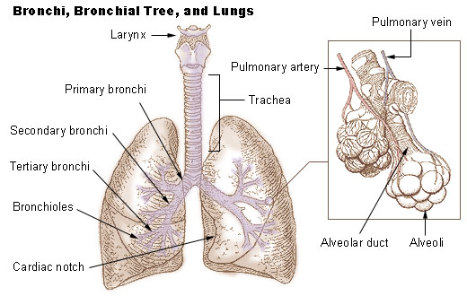
Mammalian Lungs

- Lungs are kept inside the body because air is not dense enough to support and protect these delicate structures. In addition to this, keeping them inside the body prevents loss of water and so they will not dry out easily.

- The lungs are a pair of lobed structures made up of a series of bronchioles, which end in tiny sacs called alveoli.

- The trachea (windpipe) branches into two smaller airways: the left and right bronchi, which lead to the two lungs. The left lung is longer, narrower, and has a smaller volume than the right lung it shares space in the left side of the chest with the heart. The right lung is divided into three lobes and each lobe is supplied by one of the secondary bronchi. It has an indentation, called the cardiac notch, on its medial surface for the apex of the heart. The left lung has two lobes.

- The bronchi themselves divide many times before branching into smaller airways called bronchioles. These are the narrowest airways – as small as one half of a millimetre across. The larger airways resemble an upside-down tree, which is why this part of the respiratory system is often called the bronchial tree. The airways are held open by flexible, fibrous connective tissue called cartilage. Circular airway muscles can dilate or constrict the airways, thus changing the size of the airway.

- At the end of each bronchiole are thousands of small air sacs called alveoli. Together, the millions of alveoli of the lungs form a surface of more than 100 square meters. Within the alveolar walls is a dense network of tiny blood vessels called capillaries. The extremely thin barrier between air and capillaries allows oxygen to move from the alveoli into the blood and allows carbon dioxide to move from the blood in the capillaries into the alveoli.

- Each lung is enclosed by a double-layered serous membrane, called the pleura. The visceral pleura is firmly attached to the surface of the lung. At the hilum, the visceral pleura is continuous with the parietal pleura that lines the wall of the thorax. The small space between the visceral and parietal pleurae is the pleural cavity. It contains a thin film of serous fluid that is produced by the pleura. The fluid acts as a lubricant to reduce friction as the two layers slide against each other, and it helps to hold the two layers together as the lungs inflate and deflate.
- The lungs are soft and spongy because they are mostly air spaces surrounded by the alveolar cells and elastic connective tissue. They are separated from each other by the mediastinum, which contains the heart. The only point of attachment for each lung is at the hilum, or root, on the medial side. This is where the bronchi, blood vessels, lymphatics, and nerves enter the lungs.

Section 4.2 – The mechanism of breathing

To maintain a steep concentration gradient, air must be constantly moved into and out of the lungs.

The process of breathing is called ventilation.

Air pressure in the atmosphere is greater than the air pressure in the lungs, air is drawn in. This is known as inspiration.

When air pressure in the lungs is greater than the air pressure of the outside atmosphere, air is forced out. This is called expiration.

There are two types of intercostals muscles that lie between the ribs. There is internal muscles and external muscles.
During inspiration, the external muscles contract. During expiration, the external muscles relax and the internal muscles contract.
Inspiration

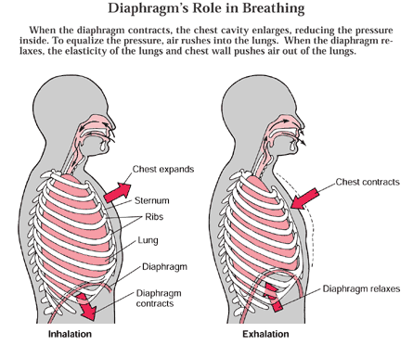
Inspiration is an active process (requires energy)
In order to respire, the internal muscles relax whilst the external muscles contract. The ribs, as a result move upwards and outwards, thus increasing the volume. The diaphragm muscle contracts, and flattens. This further increases the volume.
Due to the increase in volume, the air pressure drops, and is then lower than the air pressure outside of the lungs. Due to this, air is drawn in.

Expiration

Normally, breathing out is a passive process (requires no energy) this is because the force of gravity and the recoil of elastic muscle fibres pull the rib cage downwards and inwards.

The internal muscles contract while the external muscles relax, this decreases the volume. The diaphragm relaxes and moves back into its domed shape. This further decreases the volume. The decrease in volume causes an increase in pressure and so air is pushed out.

Pulmonary Ventilation

Pulmonary ventilation = tidal volume x ventilation rate
(dm³ min⁻¹) (dm³) (min⁻¹)

Section 4.3 – Exchange of gas in the lungs

Gas exchange is the process by which O2 moves in to the blood and CO2 moves out.

Cellular respiration creates a constant demand for oxygen.

The movement of O2 is independent of the movement of CO2.

Diffusion occurs when there is a difference in concentration.

Particles move down a concentration gradient.

Breathing in air when there is a high concentration of CO2 can be lethal even when there is a rich supply of oxygen.

CO2 will not diffuse out if the concentration is higher outside the lungs.

Gas exchange surface - where gas enters and leaves the lungs.

Single-celled organisms can use their cell membrane as a surface for gas exchange.

Many organisms have developed specialised gas exchange structures called lungs.

Alveoli.

Mammals exchange respiratory gases mainly through the alveoli.

Each alveoli is approximately 75 – 300 micrometers across.

The delicate surface area is protected from damage by being tucked away inside the chest.

Ficks law

Rate of diffusion = surface area of the membrane x difference in concentration
length of diffusion path

Having a vast number of capillaries is very important.

Walls of the alveoli are very thin and close together. This allows for efficient gas exchange.

Cells in the alveoli wall are flattened with only a thin layer of cytoplasm between the cell membranes. This reduces the distance for diffusion.

The lumen of the capillary is so narrow that the red blood cells slow down as they pass through it. They are flattened against the alveoli. This brings haemoglobin very close to the air in the alveoli.

The inner surface of the alveoli wall is covered in water, this is because the plasma membranes of its cells are permeable to water.

The film of water slows down the rate of diffusion because it has increased the distance the gases need to travel.

For a membrane to be permeable to oxygen it must also be permeable to water.

Epithelium and endothelium

Epithelial cells – cells from epithelium tissue that lines the internal and external cavity.

Endothelium is a specialised type of epithelium that lines the inner surface of blood vessels.

Alveoli structure

The wall of the alveoli is made of epithelial cells.

Surfactant

Surfactant prevents the alveoli from collapsing or sticking together.

Alveoli must be kept open to increase their surface area.

Lung surfactant reduces the surface tension so that the alveoli remain open.

Section 4.4 – Pulmonary tuberculosis

Tb is an infectious disease caused by an airborne, rod-shaped pathogen called mycobacterium tuberculosis.

Most commonly affects the lungs, causing pulmonary TB.

Almost any part of the body can be infected by the pathogen (extra pulmonary tb).

TB is the leading cause of death from bacterial infection.

The disease affects almost 1.7 billion people world wide.

It kills approximately 2 million people each year.

It is the biggest killer of women of reproductive age.

It has an extremely slow growth rate. Divides once every 16-20 hours.

Droplets of MTB can remain suspended in air for several hours.

It is very resistant, can survive several weeks in dry state.

Can survive weak disinfectants.

When a person coughs or sneezes, droplets of water are expelled and may contain the bacteria.

The disease only develops if the bacterium reaches the alveoli.

TB is referred to as invasive because it enters and spreads into tissue.
Contracting TB

Most people with TB only exhale a few bacteria in each breath. You can only contract the disease after prolonged exposure.

People who are most at risk are:
People who have HIV
Those taking immune suppressant drugs
Those under going cancer treatment
The very young/old
Those who live in LDCs
Those who inject drugs or drink too much alcohol

Skin test – the doctor would inject a very dilute extract of the bacterium into your skin. If the person has been exposed to the TB bacterium, the immune response will cause an area of inflammation.

Treatment

MTB is a bacterium that can be treated with antibiotics.

Most TB is curable using a combination of 4 different types of antibiotics.

The antibiotics are affective against most strains of the bacteria.

The drug is taken for 6 – 9 months.

Symptoms

Persistent cough
Chest pain
Coughing up blood
Chill + fever
Night sweat
Loss of appetite
Unexplained weight loss
Fatigue

Death – occurs when the sufferer has lost too much weight.

When you are most at risk

When you are in regular contact with those who have the disease
When your immune system is compromised, the bacteria could break out of the tubercles in the alveoli. They can then affect other regions of the lungs.
If the bacterium enters the blood, other areas of the body can be infected. This is called active tuberculosis.

Bacteria destroy the lung tissue, resulting in cavities and scar tissue where the lungs repair.
The loss of S.A can reduce the efficiency of gas exchange.
Fluid collects in the lungs and breathing becomes difficult.

Disease progression

Your immune system kills the bacteria and no further symptoms are experienced.

Immune system responds, bacteria are then engulfed by a type of white blood cell called macrophages which do not actually destroy the bacteria.

Tb bacteria have a cell wall made of a complex, waxy material that protects it from the macrophages.

The infection can lead to inflammation and enlargement of the lymph nodes responsible for that area of the lung.

After 3 – 6 weeks another white blood cell called T-lymphocytes arrive at the site and activate the macrophages so they can destroy the bacteria.

Lysosomes in the macrophages contain enzymes that break down the waste materials.

In a healthy person there are few, if any symptoms and the infection is controlled within a few weeks.

Active TB

The bacteria can multiply within the macrophages and eventually cause the cell to burst, releasing the bacteria.

These bacteria are then engulfed by more macrophages and the cycle continues.

Section 4.5 – Fibrosis, asthma and Emphysema

Infection

Can be caused by environmental agents such as asbestos, silica and some gases
Exposure to ionising radiation
Autoimmune response to inhaling gas containing bacterial, fungal or animal products.
Often linked with occupation

Most contaminants that reach the bronchi and bronchioles are trapped in the mucus.
Air laden with fine dust is drawn into the alveoli where there is no cilia to sweep away the particles.

White blood cells near the alveoli are called alveoli macrophages. They engulf bacteria and foreign particles.

Pulmonary fibrosis

Occurs when scars form on the epithelium causing them to become irreversibly thickened.

Patients suffering from the disease cannot diffuse oxygen into their blood as efficiently.

Diagnosed by a lung biopsy.

The fibrous tissue also reduces the elasticity of the lungs. This makes it harder to ventilate the lungs.

Shortness of breath – occurs due to the lack of oxygen diffusing into the blood as a result of the lengthened pathway and shallower concentration gradient.

Chronic dry cough – bodies reflex to try and remove fibrous tissue. However, the tissue is virtually irremovable.

Pain and discomfort in the chest – caused by the pressure and damage caused by the tissue.

Asthma

Allergens cause a chemical called histamine to be produce, which causes the airways to become thickened.

The lining of these airways become inflamed

Goblet cells secrete more mucus.

Fluid leaves capillaries and enters the lungs.

The muscles surrounding the bronchi and bronchioles contract

Difficulty breathing – due to constriction of airways

A wheezing sound when breathing – caused by air passing through restricted airways

A tight feeling in the chest – consequence of not being able to ventilate the lungs properly

Emphysema

In emphysematous tissue the elastin has become permanently stretched and the lungs are no longer able to force all the air out of the alveoli.

Shortness of breath – air cannot be ventilated as effectively. This causes the concentration gradient to become shallower. As a result, the rate of diffusion is reduced and less gas exchange will take place.

Chronic cough – bodies reflex to try and remove damaged tissue.

Bluish skin colouration – due to the lower levels of oxygen within the blood as a result of poor gas exchange

Section 5.1 – The heart and heart disease

- Mammals are too large to rely on diffusion.

- They need a circulatory system to move substances around the body.

- Blood moves down pressure gradients, from high to low pressure.

- The heart produces the main pressure gradient, although contractions of skeletal muscles also push blood along veins.

The circulatory system

- Mammals have a double circulatory system as blood passes through the twice on one complete circulation of the body.

- The pulmonary circulation pumps blood to the lungs to be oxygenated.

- The systemic circulation pumps oxygenated blood to every other part of the body that uses oxygen.

The human heart

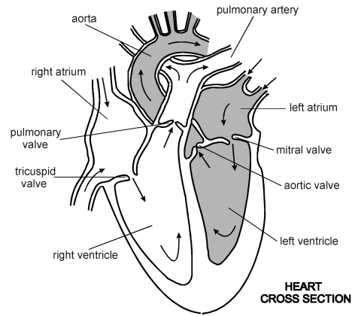
- Lies in the thoracic cavity

- Consists mainly of cardiac muscle

- Its pumping action ensures that fresh supplies of oxygen and nutrients are constantly being supplied to all living cells of the body.

- It is divided into a left and right side by a septum.

Pericardium

- The heart is covered by a double layer of tough, inelastic membranes which form the pericardium.

- Pericardium fluid is secreted by the membranes and reduces friction, allowing them to move freely over each other.

- This sac, protects the heart, anchors its surrounding structures and prevents overfilling of the heart with blood.

Heart Chambers

- The right side pumps oxygenated blood; the left side pumps oxygenated blood.

- Each side has two chambers.

- The two upper chambers are called the atria and the two lower chambers are called the ventricles.

- The atria receive blood from veins. The ventricles pump blood into arteries.

The right side of the heart

- The right atrium receives deoxygenated blood from the systemic circulation through the vena cava.

- Each atrium is elastic so it can stretch as it fills up with blood.

- Atria have only a thin muscular wall as they only need to pump blood a short distance to the ventricle.

- The right ventricle pumps deoxygenated blood through the pulmonary artery, to the pulmonary circulation.

- The pulmonary artery is the only artery to carry deoxygenated blood.

Left side of the heart

- The left atrium receives oxygenated blood from the pulmonary vein.

- The pulmonary vein is the only vein to carry oxygenated blood.

- The left ventricle pumps oxygenated blood through the aorta into the systemic circulation.

- Ventricle walls are thicker than that of the atria as they have to pump blood over a greater distance.

Ventricles

- The right ventricle pumps blood to the lungs where the left ventricle has to pump blood to the whole body.

- Although the volume of blood they hold is the same, the left ventricle has a thicker muscular wall.

- A thicker muscular wall will allow a stronger contraction to push blood further.

Valves

- There are 4 valves in the mammalian heart; one between each atrium and ventricle, and one at the base of each artery leading from the ventricles.

- The tricuspid valve between the right atrium and the right ventricle has three flaps.
- The bicuspid valve between the left atrium and the left ventricle has two flaps.

- The pulmonary semi-lunar valve is between the right ventricle and the pulmonary artery.

- The aortic semi lunar valve is between the left ventricle and the aorta.

How valves work

- They prevent the back flow of blood.

- Valves in the heart are designed to open when there is high pressure forcing the blood on the correct direction.

- If high pressure forces the blood in the wrong direction, the valves shut.

- Thin tendons join to the edges of the valve flaps to the wall of each ventricle.

- These tendons to not stretch, they stop the valves turning inside out.

Cardiac Muscle

- A special type of muscle, unlike other muscles it never fatigues.

- Does not tolerate a lack of oxygen or nutrients and soon dies if its supply of blood is cut off.

Coronary arteries

- Some of the bloody leaving the left ventricle goes to the coronary arteries.
These arteries branch out to supply the thick heart muscle with oxygen and nutrients.

- The coronary arteries are much narrower than many other arteries and so can become blocked more easily.

Section 5.2 – The cardiac Cycle

- The 4 chambers in the heart are constantly contracting and relaxing in a definite sequence.

- The cardiac cycle is the sequence of stages that take place in one heart beat.

- When a chamber is contracting it is in systole.

- When it is relaxing it is in diastole.

The stages of the cardiac cycle

- There are three stages of the cardiac cycle: atrial systole and ventricular systole and diastole.

- Atrial systole refers to the contracting of the atrial myocardium (heart muscle).

- Ventricle systole refers to the contraction of the ventricular myocardium.

- Between heart beats the myocardium of both atria and ventricles are relaxed. This is known as diastole.

- Both sides of the heart contract together. This means that the atria will contract and relax at the same time and so will the two ventricles.

Diastole

- Ventricular and atrial myocardium relaxes at the same time. Blood returning to the heart fills the atria.

- The higher pressure in the atria than the ventricles, forces the atrioventricular valves to open.

- Even though the atria aren’t contracting, blood flows from the atria to the ventricles.

Atrial systole

- The myocardium of both atria contract.

- This raises the pressure in the atria, pushing more blood into the ventricles.

- The atrioventricular valves open.

- More blood passes through these valves into the ventricles.

- Both semi-lunar valves are closed.

Ventricular Systole

- The myocardium of both ventricles contract

- The atria are relaxed

- The ventricles continue to fill with blood

- This quickly raises the pressure of the ventricles higher than that of the atria.

- Both atrioventricular valves are forced closed

- When the pressure of the ventricles exceeds that of the arteries, the pulmonary and aortic valves are forced open.

- Blood is pushed out of the heart into the pulmonary artery and aorta.

- The semi-lunar valves close, stopping blood moving back into the heart.

Pressure changes

- The events of the cardiac cycle create pressure changes.

- Pressure changes are responsible for moving blood through the heart and into the systemic and pulmonary circulations.

- Valves open or close when the balance of pressure on opposite sides of the valves changes.

Controlling the cardiac cycle
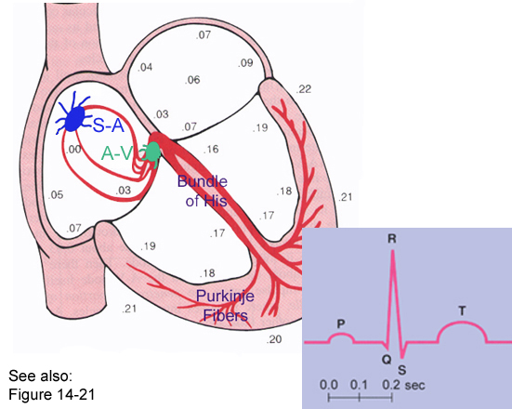
- Myogenic contractions are contractions originating from within the muscle, rather than by the nervous system.

- Myogenic contractions of the myocardium are largely responsible for the cardiac cycle.

- The cardiac cycle starts at the sinoatrial node (SA node).

- The SA node is a group of cells found out the top of the right atrium which acts as a natural pacemaker and initiates the heart beat.

- The rate at which the SA node produces the waves determines the heart rate.

- The heart rate can also be controlled by nervous impulses and hormones such as during exercise and adrenalin.

Starting the Cardiac cycle

- The SA node produces waves of electrical impulses called cardiac impulses.

- The impulses are not carried by nervous tissue but by specialised muscle fibres called purkinje fibres.

- This tissue conducts the impulses throughout the atria, stimulating the myocardium of the atria to contract.

- The contraction spreads outwards and downwards, from the top of the atria, squeezing blood towards the ventricles.

Continuing the cardiac cycle

- The electrical activity cannot pass from the walls of the atria to the walls of the ventricles, because it is stopped by a wall of fibrous tissue called the atrioventricular system.

- This stops the waves of the atrial muscle contraction continuing through the ventricle muscles as the blood would be forced to the bottom of the heart.

- There is only one location where the impulse can travel from atrium to ventricle – through the atrioventricular node. (av node)

- The AV node is another specialised group of cells.

- The cells in the AVN can conduct electricity but only shortly after a slight delay.

- The delay allows time for the atria to complete their cycle.

Contraction of the ventricles

- From the AVN two specialised bundles of purkinje tissue run down the atrioventricular septum and up the ventricular wall.

- Bundles of his conduct electrical impulses rapidly down the atrioventricular septum, to the bottom of the heart.

- These fibres stimulate the muscles of the ventricles to contract rapidly, from the base of the heart upwards.

The heart beat

- First heart beat sound “lub” occurs when the atrioventricular valves close.

- Second heart sound “dub” occurs when the semi lunar valves close.

Cardiac output

- The volume of blood from ventricles in one minute.

- Measured in dm³ min⁻¹

- The volume pumped by both ventricles pumped is the same.

- The cardiac output depends on two features: how quickly the heart is beating, and the stroke volume (amount of blood in one beat).

- Cardiac output =heart rate (min⁻¹) X stroke volume (dm³)

Section 5.3 – Heart Disease

Atheroma is the build up of fatty deposits that can impair blood flow.

If blood flow to the heart muscle is interrupted it can cause a myocardial infarction.

Atheroma

Begins as fatty streaks which are deposits of white blood cells that have taken up low density lipoproteins

These streaks enlarge to form an irregular patch, or athermanous plaque.

Athermanous plaques are made up of cholesterol, fibres and dead muscle cells.

Thrombosis

If an Atheroma breaks through the endothelium of the blood vessel, it forms a rough surface that interrupts the otherwise smooth flow of blood.

This may cause a thrombus (blood clot), which will stop the flow of blood.

The region of tissue deprived of blood due to the thrombus will not be able to respire as a result of no oxygen, glucose and other nutrients being transported to the tissue.

Aneurysm

Atheromas that form thrombosis can weaken artery wall, causing them to swell to form a balloon like, blood filled structure called an aneurysm.

Myocardial infarction

Occurs when the hear stops beating, otherwise known as a heart attack.

Smoking

Carbon monoxide combines easily, but irreversibly with haemoglobin, thus reducing the oxygen carry capability of the blood. In order to supply tissue with the same amount of oxygen the heart must work harder, thereby increasing blood pressure.

Nicotine stimulates the production of adrenalin which will increase heart rate and blood pressure.

Blood pressure

If the blood pressure in the arteries is high, the heart must work harder to pump blood into them.

High blood pressure in the arteries means there is more chance of an aneurysm forming and bursting causing a haemorrhage.

To resist the high pressure the walls of the arteries tend to become thickened and may harden, restricting blood flow.

Blood Cholesterol

High density lipoproteins remove cholesterol from tissue and transport it to the liver for excretion. They help protect arteries against heart disease.

Low density lipoproteins which transport cholesterol from the liver to the tissue, including the artery walls, which they infiltrate, leading to the development of Atheroma and hence a heart attack.

Diet

High levels of salt raise blood pressure.

High levels of saturated fat increase low density lipoprotein levels and hence blood cholesterol concentration.

Foods that act as antioxidants, e.g. vitamin c, reduce the risk of heart disease, and so does non-starch polysaccharide (dietary fibre).

Section 6.1 – Defence mechanisms

Defence mechanisms

Non-specific – mechanisms that do not distinguish between one type of pathogen and another, but respond to all of them in the same way. These mechanisms act immediately and take two forms:
- barrier of entry
- phagocytosis

Specific – Mechanisms that do distinguish between different pathogens. The response is less rapid but provides long lasting immunity. The response involves a type of white blood cell called a lymphocyte and can take two forms:
- cell mediated response (T-lymphocytes)
- Humoral responses (B-Lymphocytes)

Recognising your own cells

Lymphocytes must be able to distinguish between pathogens and the bodies own cells. If they did not, they would destroy the body’s tissue.

Defence Mechanisms
Non specific
Response is immediate and the same for all pathogens
Specific
Response is slower and is specific to each pathogen
Physical barrier
Phagocytosis
Cell mediated response. T-lymphocytes
Humoral response B-lymphocytes
- T-lymphocytes already exist within the body.

- There is over 10 million different types of T-lymphocytes.

- Given that there are so many different types of lymphocyte in the body. There is a high probability that when a pathogen enters the body the antigen on its surface will be complementary to a specific lymphocyte.

- There are very few of each lymphocyte so response to an infection is slow.

Section 6.2 – Phagocytosis

There are two different types of white blood cells. There are phagocytes and lymphocytes.

Phagocytes ingest and destroy pathogens by a process called phagocytosis.

Barriers of entry

- A protective covering – The skin covers the body’s surface, creating a barrier that is hard for pathogens to penetrate.

- Epithelia covered in the mucus – Many epithelia produce mucus. In the lungs pathogens are often caught in the mucus and moved by the cilia.

- Hydrochloric acid in the stomach – Provides a low pH that denatures the pathogens enzymes.

Phagocytosis

- Pathogens are engulfed by phagocytes in the form of vesicles which are formed on the cell-surface membrane.

- Chemical products of the pathogen act as attractants which draw the phagocyte towards it.

- Phagocytes attach themselves to the surface of the pathogen.

- They engulf the pathogen to form a vesicle known as a “phagosome”.

- Enzymes within the Lysosomes join with the phagosome and release their contents. The enzymes within the Lysosomes digest the pathogen.
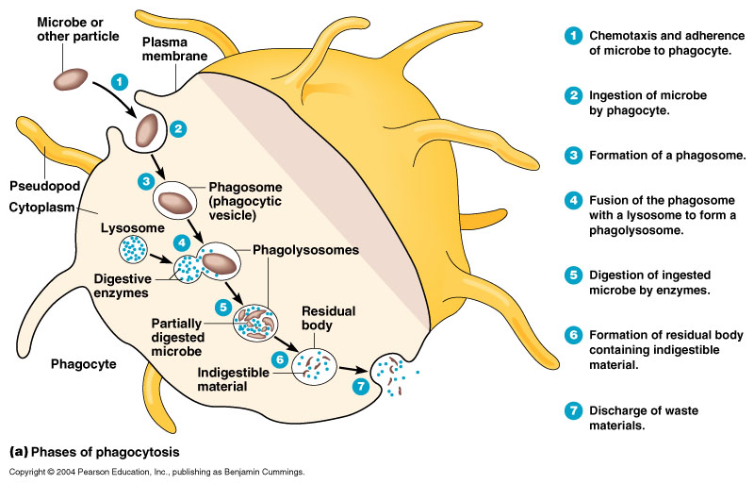
- The soluble products of the pathogen are absorbed into the cytoplasm of the phagocyte

Section 6.3 – T cells and cell-mediated immunity

Antigens

An antigen is any part of an organism or substance that is recognised as foreign and stimulates a response from the immune system.

Antigens are normally proteins that are part of the organism’s cell-surface membrane.

Lymphocytes

B –Lymphocytes are associated with humoral immunity i.e. immunity involving antibodies that are present in the body’s fluids, or “humour”.

T – Lymphocytes are associated with cell-mediated immunity i.e. immunity involving body cells.

Both types of lymphocytes are formed from stem cells in the bone marrow.

Cell-mediated immunity

T – Lymphocytes can distinguish foreign material from the bodies own tissue because:

Phagocytes have engulfed and broken down a pathogen and have presented some of its antigens on its own cell-surface membrane.

Body cells that have been invaded by a virus also manage to present some of the virus’ antigens on its surface as a sign of distress.

Cancer cells also present antigens on its cell-surface membrane.

T-Lymphocytes only respond to antigens that are attached to a body cell. This type of response is called “cell-mediated immunity”.

- Pathogens invade body cells or are taken in by phagocytes.

- The phagocyte places the antigen on its own cell-surface membrane.

- Receptors on certain T helper cells fit exactly onto these antigens.

- This stimulates other T cells to divide rapidly by osmosis to form a clone.

- The cones T cells:
a) Develop into memory cells that provided rapid response in the future.
b) Stimulate phagocytes to engulf the bacteria by phagocytosis.
c) Stimulate b cells to divide
d) Kill infected cells

T cells do not kill cells by phagocytosis. Instead, they produce a protein that makes a hole in the pathogen or infected cells. The hole then makes the cell freely permeable to all substances and quickly dies as a result.

Section 6.4 – B cells and humoral immunity

Humoral immunity is so called because it involves antibodies which are soluble in the blood and tissue fluid, also called “humour”.

A typical pathogen may have more than one type of antigen on its surface.

Toxin molecules will also act as an antigen.

Each B cell develops into two different types of cell:
Plasma cells secrete antibodies directly. They only live for a few days but produce more than 2000 antibodies every second. This is known as the primary immune response

Memory cells live for decades in some cases. When they encounter the same antigen they divide rapidly into plasma cells and more memory cells. The memory cells provide long term immunity. This is known as the secondary immune response.

- The surface antigens of the invading pathogen are taken up by the B cells.

- The B cells process the antigens and present them on their surface.

- T helper cells attach to the processed antigens and B cells thereby activating them.

- The B cells are now activated to divide by mitosis to give a clone of the plasma cells.

- The cloned plasma cells produce antibodies that exactly fit the antigens on the pathogens surface.

- The antibodies attach to antigens on the pathogens and destroy them. This is the primary immune response.

- Some B cells develop into memory cells. These can respond to future infections by the same pathogen by dividing rapidly and developing into plasma cells that produce antibodies. This is the secondary immune response.

Antigenic Variability

The antigens that pathogens are made of, and the ones they produce are constantly changing, this is known as antigenic variability. This explains why it is possible to get the same diseases more than once. Influenza for example has many different strains and so when a new strain enters the body, its antigens are not complimentary to the antigens or the memory cells produced from the last infection. Due to this the most use its primary immune response.

Section 6.5 – Antibodies

Antibodies are proteins synthesised by B cells.

Antibodies react with antigens by binding with them.

Structure

Antibodies are made up of four different polypeptide chains.

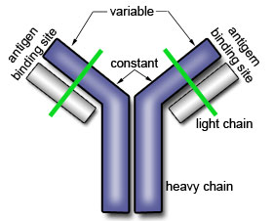
The chains of one pair are long and are called heavy chains, while the other pair have shorter chains and are called light chains.

Antibodies have a binding site that is very specific to the antigen once together they form and antigen-antibody complex

The binding site is different for all antibodies and is known as the variable region.

The rest of the antibody is the same and is called the constant region.

Monoclonal antibodies

A pathogen entering the body is likely to have hundreds of different antigens on its surface. Each antigen will induce a different B cells to divide and clone its self. Each clone will produce a different antibody known as a polyclonal antibody.
Antibodies that can be isolated and cloned are called monoclonal antibodies.

Monoclonal antibodies have a number of uses such as:

The separation of a chemical from a mixture

Immunoassay- this is the method of calculating the amount of substance in a mixture. It is used in pregnancy testing kits, testing for drugs in the urine, and detecting the immunodeficiency virus (aids test)

Cancer treatment – it is possible to manufacture monoclonal antibodies that will attach themselves to cancer cells. They will then activate a cytotoxic drug that will kill cells. This drug will only be activated by cells to which the antibody is attached.

Transplant surgery – Even with close matching the transplanted tissue will experience some rejection from the T – cells. Monoclonal antibodies can be used to knock out these T – Cells.

Section 6.6 – Vaccination

Passive immunity is produced by the introduction of antibodies into individuals from an outside source. As the antibodies are not being produced by the individuals themselves, they are not being replaced when they are broken down in the body and so the immunity is generally short-lived.

Active immunity is produced by stimulating the production of antibodies by the individuals own immune system. In is generally long-lasting.

Vaccination is the injection of a substance into the body with the intention of stimulating active immunity.

Features of a successful vaccination program

- The success of a vaccination program depends on a number of factors:

- A suitable vaccine must be economically available in sufficient quantities

- There must be very few if any unpleasant side effects from the vaccine.

- Means of producing, storing and transporting the vaccine must be available.

- There must be the means of administrating the vaccine at the right time.

- It must be possible to vaccinate the vast majority of the vulnerable population.

Why vaccination does not eliminate a disease

- Vaccination fails induce immunity amongst some individuals.

- Individuals may develop the disease immediately after vaccination but before their immunity levels are high enough to prevent it.

- Pathogens may mature rapidly so that their antigens change suddenly rather than gradually. This is due to the antigenic variability.

- There may be many varieties of a particular pathogen.

- Certain pathogens can hide from the body’s immune system by hiding themselves with cells or by living in places that are out of reach.

The problems of controlling cholera and tuberculosis by vaccination

- Cholera is an intestinal disease and is not easily reached by the immune system.

- The antigens on the cholera surface change rapidly.

- The increasing amounts of people with HIV has led to more people having impaired immune systems and so are more likely to contract TB.

- The proportion of elderly people in the population is increasing. These people have less effective immune systems and so vaccination is less effective at stimulating immunity.

